CONTENTS
EXECUTIVE SUMMARY 3
INTRODUCTION 5
1. DEVELOPMENT OF THE INDICATOR 7
1.1 Background 7
1.2 Measuring fuel poverty at small area level 8
1.3 Local House Condition Surveys 8
1.4 ‘Proxy’ indicators 9
1.5 Indicators of low income 9
1.6 Indicators of poor housing 12
1.7 Indicators of fuel poverty 12
1.8 Conclusion 15
3. DEVELOPING A CENSUS-BASED FUEL POVERTY INDICATOR 17
3.1 Introduction 17
3.2 Census-based deprivation indicators 17
3.3 Who is likely to live in fuel poverty? 17
3.4 Obtaining weightings for a Census-based Fuel Poverty Indicator 18
3.5 Measuring fuel poverty using the 1991 Census 19
3.6 Predicting fuel poverty at a local level 20
3.7 Conclusion 21
4. VALIDATION OF THE FUEL POVERTY INDICATOR 23
4.1 Peer group review 23
4.2 Comparison with local surveys of fuel poverty 23
4.3 Using the EHCS as a means of validation 25
4.4 Conclusion 26
5. FURTHER DEVELOPMENT OF THE INDICATOR 27
5.1 Output Areas 27
5.2 Work required 27
5.3 Outputs 28
5.4 Potential uses of the Fuel Poverty Indicator 28
5.5 Conclusion 31
6. PROFILING FUEL POVERTY IN THE SOUTH WEST 33
6.1 Introduction 33
6.2 Incidence of fuel poverty 33
6.3 ‘Concentrations’ of fuel poverty 35
6.4 Comparing fuel poverty in the South West and England 37
6.5 Conclusion 37
REFERENCES 39
APPENDIX 1 – Comparison of FPI with other indicators 41
A1. Comparison of the FPI with ‘general’ deprivation indicators 41
A2. Comparison of FPI with incidence of prepayment meters 44
A3. Comparison of FPI with excess winter deaths 45
APPENDIX 2 – County Profiles 49
APPENDIX 3 – ‘Worst’ 10% of wards in South West 53

EXECUTIVE SUMMARY

This report describes work undertaken by the Centre for Sustainable Energy (CSE) and Bristol University to develop a methodology for predicting fuel poverty at small area level. The project was funded by SWEB, the main electricity supplier in South West England, to fulfil two aims. First, SWEB felt that a small area fuel poverty indicator would help the company target its Energy Efficiency Commitment programme and other anti-fuel poverty initiatives. Second, SWEB believed the project would help to develop best practice within the energy industry.

We consider we have successfully met the project’s aim. We have developed a small area “Fuel Poverty Indicator” (FPI) that is capable of predicting the number and proportion of households in fuel poverty for every ward in England. We have therefore exceeded the original brief, which was to produce an indicator for South West England alone (or rather SWEB’s original supplier area). We can also produce results for other geographies, including, at the smallest level, enumeration district.

The FPI is based on the 1991 Census. It represents a predictive model of fuel poverty, for which data from the 1996 English House Condition Survey was used to produce ‘weightings’ for the FPI’s component Census variables.

We are currently in the process of validating the indicator. The limited validation conducted to date suggests that the indicator is sound. However, we would welcome comments on our overall approach.

We intend to update the FPI as soon as data from the 2001 Census and 2001 English House Conditions Survey is made available. This will involve repeating the modelling and statistical work with the new data sets. Once we have completed this exercise, we believe the updated FPI will prove a very powerful indicator of fuel poverty. This is because the new Census output areas, which replace enumeration districts, are based on homogenous housing characteristics.

An Appendix to the report illustrates the type of analyses that are feasible with the FPI. We have investigated, for example, the relationships between the FPI and the incidence of prepayment meter users and excess winter deaths.

We have posted the FPI results for every electoral ward in England on the websites of CSE and Bristol University (www.cse.org.uk and www.bris.ac.uk/poverty). We have also posted an interactive map of the distribution of fuel poverty for South West England.

INTRODUCTION

This report describes work undertaken by the Centre for Sustainable Energy (CSE) and Bristol University to develop a methodology for predicting fuel poverty at small area level. The project was funded by SWEB, the main electricity supplier in South West England, to fulfil two aims. First, SWEB felt that a small area fuel poverty indicator would provide a valuable tool for informing the targeting of the company’s Energy Efficiency Commitment programme and other anti-fuel poverty initiatives. Second, the company considered the project would help to develop best practice within the energy industry.

At the outset, when SWEB contributed funding, there was no guarantee that the project would be successful. In the event, we believe that we have developed a robust indicator that will prove valuable to many potential users. We are very grateful to SWEB for their support during the project and for agreeing to make the results of our work public.

Our “Fuel Poverty Indicator” (FPI) predicts both the number and proportion of households in fuel poverty in England for any geography required, i.e. the indicator results can be produced at a variety of resolutions. These include:

- Government Office region
- Parliamentary Constituency
- Local Authority District
- Electoral Ward
- Enumeration District

We are able to produce results at different resolutions because the FPI is based on the 1991 Census. The FPI is a predictive model of fuel poverty, for which the 1996 English House Condition Survey was used to produce ‘weightings’ for the FPI’s component Census variables. This report focuses on analysis of the FPI at electoral ward level. We have posted the results for every electoral ward in England on the websites of CSE and Bristol University (www.cse.org.uk & www.bris.ac.uk/poverty). This will enable other researchers to reproduce the results for larger areas, as required.

It is not feasible to publish the results for every Enumeration District in England, because of the sheer size of the database. However, we can produce results at this level as a ‘be-spoke’ service for interested parties.

Although our original brief from SWEB was to develop a small area indicator for the South West only (plus advice on how to extend this to London), the methodology we eventually developed allows us to predict fuel poverty for the whole of the country. This report shows the results of mapping the indicator for the South West. However, it is relatively straightforward to produce similar maps for other regions. Please note, that the South West maps are based on SWEB’s traditional catchment area, rather than the Government Office South West region.

We are currently in the process of validating the indicator (described later) and will continue to do this. The limited validation conducted to date suggests that the indicator is sound. However, we would welcome comments on our overall approach, described in this report and accompanying papers.

The report is structured as follows:

Development of the indicator – this describes our early work in approaching the task, for example the indicators investigated and the rationale for selecting and rejecting potential single indicators that might make up a composite fuel poverty indicator.

Developing a Census-based fuel poverty indicator – this gives a brief account of the methodology eventually adopted for compiling the Fuel Poverty Indicator. A fuller account is given in Gordon, 2002.

Validation of the indicator – this describes the current and future planned work to validate the indicator.

Future development – this describes the work we intend to undertake to update the indicator, using 2001 Census and 2001 English House Condition Survey data. We also suggest some possible uses for the indicator, although we envisage fuel poverty researchers and practitioners will identify many others.

Results for the South West – this gives a brief analysis of the distribution of fuel poverty in the South West, using the Fuel Poverty Indicator.

Appendix1 – this describes the results of some brief analyses that compare the FPI with other indicators, such as excess winter deaths and ppm use.

Appendix 2 – this profiles the distribution of fuel poverty for each of the counties in the South West.

Appendix 3 – this lists the 10% of ‘worst’ wards in the South West on the Fuel Poverty Indicator.

This report represents the second phase of the ‘fuel poverty profiling’ project. It builds upon an earlier report CSE produced for SWEB that described the distribution of ‘vulnerable groups’ in the South West (CSE, 2001). Copies of the first report are available from CSE.

DEVELOPMENT OF THE INDICATOR

Background

The term ‘fuel poverty’ describes the interaction between low income, poor access to energy services, poorly insulated housing and inefficient heating systems. While fuel poverty, low income households and housing energy efficiency are all closely related, there are clear distinctions between them that need to be understood and considered in developing a small area fuel poverty indicator. The relationship can be illustrated by the following diagram (National Right to Fuel Campaign, 2000a):

Low
income Energy inefficient
housing

Fuel
poverty

The standard definition of a fuel poor household is one that needs to spend more than 10% of its income on all fuel use to heat the home to an adequate standard and for meeting its needs for lighting, cooking and running domestic appliances (see, for example, DTI/DEFRA, 2001). The definition of a ‘satisfactory standard of heating’ varies according to household type (DETR, 2000a):

- For households in work or fulltime education, the standard is 21°C in the living room and 18°C in the other occupied rooms for the whole house for 9 hours a day (morning & evening) – this is termed the Standard heating regime.
- For households likely to be at home all day, the standard is 21°C in the living room and 18°C in the other occupied rooms for the whole house for 16 hours a day (all day) – this is termed the Full heating regime.
- For under-occupied households, the standard is 21°C in the living room and 18°C in the other occupied rooms for half of the house for 16 hours a day (all day) – this is termed the Partial heating regime.

It is important to appreciate that this definition of fuel poverty is based on what households need to spend on fuel, rather than what they actually spend. The above definition of heating regimes is based on internal temperatures recommended by the World Health Organisation to maintain good health.

The Government prefers to define income as including Housing Benefit or Income Support for Mortgage Interest, although it also gives information on a definition that excludes these benefits from income (DTI/DEFRA, 2001). Many fuel poverty organisations prefer an income definition that is based on disposable income (see NRFC, 2002a). This is because the ‘disposable income definition’ prevents a household’s fuel poverty status being influenced by such extraneous factors as local house prices or rents. The ‘disposable income’ definition excludes housing costs from income.

Calculation of the level of fuel required to maintain adequate warmth is based on a technical assessment of a property’s energy efficiency standard. The Government’s method for assessing energy efficiency is referred to as the Standard Assessment Procedure. The SAP scale ranges from 1 (very poor) to 100 (excellent).

Measuring fuel poverty at small area level

It is possible to obtain figures for the number of fuel poor households at a national and regional level from the English House Condition Survey (EHCS). The EHCS is a national survey that until recently was run every 5 years. The survey comprises both an interview with the household and a physical inspection of the property by a qualified surveyor to obtain a SAP rating. By combining income and SAP data, it is possible to determine a household’s fuel poverty status. A sample of 17,500 households was interviewed for the 2001 EHCS, with results due in December 2002. From April 2002, the survey will be run continuously with a sample size of 8,000 (DTLR, 2002a).

The sample size for the EHCS is not sufficient to produce results for areas any smaller than Government Office Regions. The only truly accurate method of obtaining fuel poverty data at small area level is to conduct a representative survey of properties at the small area level using a similar methodology to the EHCS.

In investigating the development of a small area fuel poverty indicator, our initial work focused on exploring two routes:

- Use of local authority House Condition Surveys
- Investigation of ‘proxy’ indicators for low income, poor housing conditions and/or fuel poverty itself

The following describes the results of this work.

Local House Condition Surveys

We asked all local authorities in the South West to send us copies of their local House Condition Surveys. These are primarily conducted to assess the number of ‘unfit’ houses in local authority areas, although many surveys now include information on energy efficiency standards. Only a small number of authorities responded to our request. Several more authorities replied that they had not conducted local surveys for some considerable time (over 10 years).

None of the surveys we received calculated the number of fuel poor households at ward level (or to that matter, district level). Some gave average SAP ratings for private sector housing in the district; some gave average SAP ratings for public sector housing at ward level.

It might have been possible to arrive at a figure for fuel poverty numbers by combining SAP information with a proxy for low income. However, this information was not consistently collected by all local authorities. We therefore decided that local House Condition Surveys were not a useful option to pursue for the time being. They might become more useful in the future should:

- The Office of the Deputy Prime Minister (ODPM) provide clearer and more detailed guidelines on the content of future local House Condition Surveys.
- Such guidelines include standardised approaches to collecting SAP data within samples of households at ward level across all housing sectors.
- Guidelines also include standardised approaches to collecting income information. The Office of National Statistics, for example, has developed a protocol for including a simple income question within general questionnaires.
- Local authorities supplied SAP, income and fuel poverty data (the latter would be obtained by combining the first two indicators) to a central point which took responsibility for collating and producing databases of the results.

We suspect that the above is not likely to occur in the short term. However, we suggest it is a feasible approach and would certainly aid implementation of the Government’s Fuel Poverty Strategy at the local level. This is because local authorities are obliged to periodically conduct local House Condition Surveys. It would be relatively straightforward to obtain the additional information required for assessing fuel poverty status. The Government’s pilot Warm Zones, for example, have already developed a simple form for assessing households’ fuel poverty status, although their approach has yet to be validated (EST, 2002).

‘Proxy’ indicators

In the absence of any direct local measures of fuel poverty status, we then investigated the use of possible ‘proxy indicators’ for low income, poor housing and/or fuel poverty itself. By exploring a range of small area single indicators, we aimed to weight and combine these into a single ‘composite’ indicator of fuel poverty. This would be achieved through a statistical modelling exercise using EHCS data (supplied by ODPM). The following gives a brief overview of the indicators investigated.

Indicators of low income
Indicators based on benefit status

Commonly used indicators of low income are those based on households’ benefit status. Most State benefits are means-tested. The Benefits Agency assesses claimants’ household circumstances to establish whether their income is sufficiently low to warrant the award of benefits. The Benefits Agency takes into account such factors as number of dependents, disability and income from earnings, pensions and/or savings. Households in receipt of Income Support receive little income from other sources and are only able to meet very basic needs.

The number of claimants of Income Support and/or the various disability benefits is therefore a good proxy for low income. It allows for differing household size and circumstances. Furthermore, the ODPM (formerly the Department of Transport, Local Government and Regions) provides data on both numbers and proportions of households within each English ward claiming means tested benefits. This is the income domain within the Index of Multiple Deprivation (IMD) (DTLR, 2000b). It is also possible to obtain data on the individual benefits making up the income domain from the ONS. We obtained the following databases (numbers and proportions of claimants at ward level):

- Attendance allowance
- Disability Living Allowance
- Family Credit
- Incapacity benefit
- Income Support
- Job Seekers Allowance
- Severe Disability Living Allowance

A key problem with the ‘income domain’ and other benefit databases is that many low income households do not claim the benefits to which they are entitled. This problem is particularly acute among older and/or rural households (see, for example, DWP, 2002 and Bramley et al, 2000). Between 22 and 36% of eligible older households do not claim Income Support (DWP, 2002). Given that older people make up over ½ of the fuel poor population (DEFRA/DTI, 2001), the use of the income domain as a component measure within an overall fuel poverty indicator is problematic.

In addition, many of the fuel poor are not eligible for benefits. This issue is discussed in greater detail in the next chapter. In brief, we suggest that by living in energy inefficient housing, certain groups of households living on modest incomes but above benefit levels are pushed into fuel poverty. Early results from the Government-sponsored Warm Zone pilots suggest that this group is quite large. Warm Zones systematically assess household fuel poverty status on an area basis. They have found that a least one third of households in fuel poverty are not eligible for Warm Front grants, because they do not claim the requisite passport benefits (EST, 2002).

Other IMD deprivation indicators

The Index of Multiple Deprivation (IMD) (DTLR, 2000b) is widely used by researchers as a general small area deprivation indicator. The Government bases many funding decisions on individual wards and districts’ rank on the Index, e.g. SRB funds, allocation of resources to local authorities (through the Standard Spending Assessment). It should be noted that the IMD only goes down to the level of electoral wards. It does not provide information at the sub-ward level, e.g. enumeration district, 6 digit postcode.

In the absence of any small area fuel poverty indicator, some fuel poverty researchers and programme deliverers have used the IMD as a proxy for fuel poverty, e.g. the prioritisation of wards for time tabling works within Warm Zones (EST, 2002).

The Index consists of 6 domains, plus a separate child poverty indicator. These are:
- income deprivation
- housing deprivation
- health deprivation and disability
- education skills and training deprivation
- employment deprivation
- geographical access to services.

The child poverty indicator is a subset of the income domain and consists of children living in households dependent on benefits. The overall Index represents the weighted combination of the 6 individual domains.

The criteria for setting weights in the IMD were that the income and employment domains should carry more weight than the other domains and that the domains with the most robust indicators should be given the greatest weights (DETR, 2000b). The individual weightings were decided following consultation and sensitivity testing. Income deprivation was regarded as a core aspect of multiple deprivation and worklessness as a deprivation in its own right, and not simply a driver for low income (DETR, 2000b). However, ultimately the weights were selected according to ‘informed judgement’ (DETR, 2000b, p58).

We did not select any of the individual domains within the IMD, although we did correlate several with the Fuel Poverty Indicator we eventually developed (see Appendix 1). We also analysed the distribution of two IMD domains (‘health deprivation and disability’ and the child poverty index) for our profile of vulnerable groups in the South West (CSE, 2001).

Indicators based on the Census

The Census does not directly measure household income, although measurement was considered (and rejected) for the 2001 Census. However, social scientists have developed certain proxies for low income from measures that are contained within the Census. These include, for example, ‘unemployment’ and ‘no access to a car’. In addition, certain groups have been found to be highly correlated with low income, e.g. single pensioners, lone parents, disabled households.

All of these proxies are problematic; for example, car ownership penetrates much further down the income scale in rural areas than it does in urban. This is because owning a car is considered an essential necessity by people living in rural areas, due to dispersed settlement patterns, local services and social networks and poor public transport provision. Similarly, not all lone parents or single pensioners live on a low income (just a much higher proportion than the general population).

Indicators of poor housing

Unfortunately, there are currently no adequate small area indicators for poor housing conditions. As commented earlier, it is disappointing that more effort is not made to collate local authority House Condition Survey data or even HECA data (Home Energy Conservation Act). We understand London local authorities have collated some information at the London-wide level. However, this exercise has not repeated outside London.

The ‘housing deprivation domain’ within the Index of Multiple Deprivation is a relatively ‘weak’ indicator of housing deprivation since it does not contain any measure of poor housing condition. The domain includes indicators of homelessness and overcrowding. The first bears no relationship to fuel poverty, while the latter is, if anything, inversely related (see next chapter).

The Census has traditionally emphasised ‘lack of amenities’ as an indicator of housing deprivation. A typical Census measure includes ‘lack of exclusive use of a bathroom and toilet’. Since this problem now only applies to 1% of households, it represents a poor indicator of inadequate housing conditions.

Another possible Census indicator is social housing and/or private renters. Both groups are more likely to live in housing deprivation. However, while energy efficiency standards are particularly low in the private rented sector, they are above average in the public sector (DETR, 2000a). This reflects the higher priority social landlords have given in recent years to energy efficiency investment.

There is considerable evidence that certain groups are highly likely to live in poor housing, e.g. lone parents, single pensioners, pensioner households (DETR, 2000a). These indicators are therefore also likely to reflect poor housing, as well as low income.

Indicators of fuel poverty

We investigated a number of proxy indicators for fuel poverty itself. These included electricity consumers in arrears, electricity consumers paying by ppm, excess winter deaths, lack of central heating and under-occupation. The first two indicators were based on information provided by SWEB.

Ideally, we would have also liked to investigate energy consumption. However, SWEB stated this would have been very difficult to collate, although technically feasible. Furthermore, SWEB would have only been able to supply electricity information, making it difficult to compare households who use electricity as their main source of heating with those who use gas.

With respect to arrears, SWEB reported that on average around 2000 households had arrears of more than 3 months duration across the whole of the SWEB area at any one point in time. This rendered the indicator impractical at a small area level, due to the small numbers involved.

Prepayment meters

SWEB’s prepayment meter (ppm) database proved more promising. We undertook a major exercise in converting postcode data on incidence of electricity ppm use to ward data to allow us to compare this indicator with other indicators collected. We considered the indicator might represent a possible proxy for fuel poverty.

Ofgem and industry representatives have long argued that ppm use is a poor proxy for fuel poverty (see, for example, Electricity Association Fuel Poverty Task Force, 2001). There is considerable evidence that ppms are predominantly used by households on low incomes. For example, 32% of households in social class DE, 51% of lone parents and 37% of households with an annual income below £4.5k pay for electricity by ppm, compared to 2% in social class AB (Ofgem, 2001).

However, a substantial proportion of the fuel poor do not use ppms. Most significantly this includes older people, who make up over half the fuel poor (DTI/DEFRA, 2001). 13% of older people pay for electricity by ppm at the national level, a much lower proportion than other low income groups, although only a little lower than the national figure of 16% (Ofgem, 2001).

Prepayment meters have also been strongly associated with debt – a problem commonly associated with fuel poverty. Certainly, there is a striking parallel between the growth of use of ppms over the past decade and the decline in disconnections for bad debt. Between 1991 and 2000, the number of consumers paying for electricity by ppm rose from 1.2m to 3.5m. By contrast the number of electricity disconnections declined over the same period from 47,910 to 300 (Electricity Association Fuel Poverty Task Force, 2001).

However, many low income electricity consumers choose to pay by ppm because of the budgeting facility it offers. Only about 17% of electricity ppm users pay this way because of past debt. In effect, use of ppms represents a coping strategy for people living on a low income. Users know that they do not have to worry about paying bills and that they can budget their consumption. However, users pay more for this method of paying than any other payment method, often ration their use of fuel in line with their limited income and are excluded from the competitive offers available to people who pay by other payment methods (CSE, 2001a).

Use of ppms is also common in areas with large student populations, due to the latter’s transient nature. However, students are not typically associated with fuel poverty on the grounds that their situation is considered only temporary. Of course, many students live in poor quality housing that would benefit from energy efficiency investment.

After consideration of the above factors, we decided to reject ‘incidence of ppm use’ as a possible indicator. However, we did explore the association between ‘incidence’ and the eventual Fuel Poverty Indicator we developed (see Appendix 1).

Excess winter deaths

Debbie Lawlor of Bristol University’s School for Social Medicine has developed a ward level excess winter deaths index by aggregating 5 years of excess winter deaths data for the South West (numbers at ward level for any single year are fairly small) (Lawlor, unpublished). We considered using this as an indicator but for various reasons (see below) rejected this option. Instead, we decided to use the results as a possible means for validating the Fuel Poverty Indicator we eventually produced.

There is considerable evidence that excess winter deaths are related to low indoor temperatures and poor thermal efficiency (see, for example, Wilkinson et al, 2002). However, several studies have found that there is no relationship between deprivation and excess winter deaths (Lawlor et al, 2000; Shah & Peacock, 1999). Wilkinson’s research similarly did not find any correlation between socio-economic status and excess winter deaths and felt that this finding was counter-intuitive:

“without adjustment for other factors, the gradient inclines towards a higher risk (of winter mortality) in the professional and managerial grades and a lower risk in unskilled and semi-skilled workers” (Wilkinson et al, 2002, p20).

Given the lack of relationship between general deprivation and excess winter deaths, we considered that the latter was unlikely to be a good indicator of fuel poverty. While we recognised the differences between fuel poverty and general poverty, the relationship between excess winter deaths and deprivation is so weak that we decided against the former’s selection as a fuel poverty indicator.

Given the strong association for many between excess winter deaths and fuel poverty, the lack of apparent relationship is somewhat disturbing (see, for example, Wilkinson’s discussion, Wilkinson et al, 2002). Certainly it is apparent that the relationship needs further investigation. Our analysis of Debbie Lawlor’s index, for example, suggests that there may be a rural dimension to excess winter deaths (see Appendix 1). One implication is that different policy instruments may be required for tackling fuel poverty and excess winter deaths.

Indicators based on the Census

The main Census indicator related to fuel poverty is ‘lack of central heating’. Central heating, in general, enables households to maintain reasonable temperatures within the home and is a cheaper means of keeping the whole home warm (compared to single point heaters). However, the Census does not establish the age of the heating system nor whether it is partial or full central heating. These factors have a considerable bearing on a property’s overall energy efficiency rating. This problem also applies, incidentally, to the English House Condition Survey.

Despite these shortcomings, we considered ‘lack of central heating’ as potentially a useful component indicator for a composite fuel poverty indicator.

Another possible Census indicator is ‘under-occupation’. The UK Fuel Poverty Strategy refers to the contribution of under-occupation to fuel poverty (DTI/DEFRA, 2002). This is because it costs households a lot more to heat large properties that exceed their needs than smaller properties. The problem is typically associated with older households where children have left the family home. For this reason, under-occupation is likely to be highly correlated with pensioner households.

We therefore considered ‘under occupation’ would potentially be a useful component indicator for a composite fuel poverty indicator. However, we developed a different measure of under-occupation to that used by the EHCS (see next chapter).

Conclusion

The above describes our investigations into possible indicators of factors related to fuel poverty. It is likely that we omitted a number of potential sources, for example Warm Front operational data or health data, such as incidence of cardiovascular disease. The Energy Efficiency Partnership’s Fuel Poverty Strategy Group has established a data sub-group to explore possible data sources for investigating fuel poverty at a local level (see EST website, for further details of Partnership working groups). This may reveal other possible sources than those discussed above.

We decided to focus our efforts on developing a fuel poverty indicator based on Census measures. The Census is currently the only reliable source of high quality statistical information at a small area level. There is a long tradition of using the Census to develop general deprivation indicators, e.g. the Townsend Index (Townsend et al, 1988). We felt that the Census could also potentially provide proxy indicators for fuel poverty and its constituent elements (primarily poor housing and low income). A Census-based fuel poverty indicator would also have the advantage of allowing fuel poverty to be predicted for any geography required (including sub-ward level). The following chapter describes the results of our work.

DEVELOPING A CENSUS-BASED FUEL POVERTY INDICATOR

Introduction

This chapter gives an overview of the methodology developed by David Gordon of the University of Bristol’s Townsend Centre for International Poverty Research to predict the incidence of fuel poverty at small area level, using 1991 Census data. It represents a brief summary of the methodology adopted. A fuller account is given in Gordon, 2002. The approach draws upon a long history of using the Census for developing indicators of general deprivation.

Census-based deprivation indicators

All Census-based deprivation indicators tend to consist of proxy measures of deprivation, rather than direct measures. Because of this, there are two basic requirements indicators should fulfil to ensure accuracy:
- the indicator’s individual components should be weighted to reflect the different probability each component group has of suffering deprivation; and
- the individual components of the indicator must be additive, i.e. if an indicator consists of two variables, e.g. unemployment and lone parents, researchers must be confident that unemployed lone parents are likely to be poorer than either lone parents in employment or unemployed people who are not lone parents.
Weighted indicators also have the advantage that the results are much easier to understand. For example, it allows the researcher to make the statement that “15% of households in the South West live in fuel poverty”, rather than “the South West has a fuel poverty Z score of -2.6”.

This protocol was therefore followed in developing the Fuel Poverty Indicator. In doing this, a number of a priori assumptions were made about the type of household most likely to live in fuel poverty.

Who is likely to live in fuel poverty?

By drawing upon previous research on propensity to live in fuel poverty (e.g. Boardman, 1991; DTI/DEFRA, 2001; NEA, 2001), it is possible to identify two categories of fuel poverty:
- People with a relatively low income. Groups known to suffer from high rates of relative poverty, e.g. lone parents, unemployed people, are also likely to suffer from high rates of fuel poverty. However, there are exceptions. Some social housing tenants, for example, live in properties with high energy efficiency standards, meaning that although they may have low incomes, they do not live in fuel poverty.
- People with low/moderate incomes living in energy inefficient housing. This group may have an overall standard of living above the relative poverty threshold. However, the poor energy efficiency standards of their housing (coupled with, in some cases, under-occupancy) may push this group into fuel poverty. Single pensioners living in poorly insulated older dwellings make up the bulk of this group. Fuel poverty, in this case, is largely a problem of heating unmodified pre- WWII housing stock combined with relatively low pension incomes.
Following this analysis, it is possible to investigate the propensity of different groups’ likelihood of living in fuel poverty.

Obtaining weightings for a Census-based Fuel Poverty Indicator

The easiest method of obtaining weightings for component variables in a Census-based Fuel Poverty Indicator is to use a survey that accurately measures fuel poverty. Ideally, this should be conducted at or around the same time as the Census. The 1996 English House Condition Survey was used for this purpose, since this provides information on the likelihood of groups living in fuel poverty (defined as ‘households needing to spend more than 10% of their income on fuel’).

Weightings were also obtained for a definition of fuel poverty based on households’ actual expenditure on fuel, using the 1992 Family Expenditure Survey results (now known as the Expenditure and Food Survey). David Gordon’s paper describes the results of the variables selected and the weightings obtained from FES (Gordon, 2002). This report focuses on the ‘required expenditure on fuel’ definition of fuel poverty, since this is the definition most commonly used by fuel poverty practitioners.

A further complication arose when investigation of the 1996 EHCS dataset revealed that there was no variable for households’ total required fuel costs for all energy needs, although it did contain a variable for required fuel costs for heating needs. Julie Dunster from BRE and Terry McIntyre from DEFRA therefore reproduced the ‘all fuel costs’ variable from the EHCS dataset for this study. However, the re-modelled variable differs in minor respects from the original analysis for the EHCS Energy Report (DETR, 2000a).

Table 1 below gives the relative risk ratios for different groups’ likelihood of living in fuel poverty. The ratios do not allow for possible overlap between different variables. The choice of variables is based on a priori assumptions about the likelihood of different groups’ propensity to live in fuel poverty, as outlined above.
Table 1: Univariate Odds (Relative Risk Ratios) of Census 1991 variables as predictors of fuel poverty in the 1996 EHCS
Variable | Total Fuel Cost (N=13,711)
No car | 3.0
Single Pensioner | 2.7
Under occupied (> 5 rooms per person) | 2.4
No central heating | 2.2
Unemployed | 2.1
Private renter | 1.9
Disabled | 1.7
Lone parent | 1.6
LA or RSL renter | 1.6
Overcrowded (> 1 person per room) | 0.8
Source: Gordon, 2002; 1991 Census; 1996 EHCS

Table 1 shows that households without access to a car were three times more likely to be living in fuel poverty than the rest of the population. Single pensioners, under-occupied households (more than 5 rooms per person), households without central heating and unemployed households were more than twice as likely to be living in fuel poverty. Conversely, households in overcrowded accommodation (more than one person per room) were slightly less likely to be living in fuel poverty than the general population.

It is for the latter reason that the housing deprivation domain within the IMD was considered inappropriate as a proxy indicator of fuel poverty (see previous chapter). This is because ‘overcrowding’ is a key component of the ‘housing deprivation domain’.

The definition of under-occupation used above was obtained by using CHAID (chi-squared automatic interaction detector) analysis. This determined the optimum threshold level for under-occupancy (in terms of number of rooms per person) in order to predict fuel poverty. Obviously, it differs from standard definitions of ‘under-occupation’ (see, for example, NRFC, 2002b).

Measuring fuel poverty using the 1991 Census

Weightings were obtained for the best subset of fuel poverty indicator variables, measured in both the 1991 Census and 1996 EHCS, by using a multi-variate statistical technique of logistic regression (Gordon & Forrest, 1995; Gordon, 1995). This approach has been successfully used in developing other deprivation indicators, e.g. Breadline Britain (Gordon & Forrest, 1995).

Initially, 11 variables were selected as potential predictors of fuel poverty (as shown by previous studies, e.g. DETR, 2000; NEA, 2000). These variables were also measured in similar ways in the EHCS and the Census. The 11 variables were:

- Unemployed; households with an adult under 60 unemployed
- Lone Parents: households with dependent children and one adult
- Under occupied: households with more than 5 rooms per person
- Overcrowded: households with more than one person per room
- No Central Heating: household with no central heating
- No Car: households with no access to a car
- Renting: households in rented accommodation (LA and private)
- Private Renter: households in accommodation rented from a private landlord
- LA/RSL Renter: households renting from a social landlord
- Single Pensioner: households with one adult aged over 65, if a man, or over 60, if a women
- Disabled: household with at least one sick/disabled member

The step-wise logistic regression allowed the best sub-set of variables to be selected that were proxies of fuel poverty and provided weightings for each variable, after allowing for overlaps between variables. Table 2 below gives a summary of these multi-variate analyses.

Table 2: Multivariate Odds (Relative Risk Ratios) of Census 1991 variables as predictors of fuel poverty in the 1996 EHCS
Variable | Total Fuel Cost (N=13,711)
Unemployed | 2.9
Under occupied (> 5 rooms per person) | 2.6
No car | 2.5
Single Pensioner | 2.4
No central heating | 2.4
Private renter | 2.1
Lone parent | 2.1
Disabled | 1.6
Source: Gordon, 2002; 1991 Census; 1996 EHCS

Once the overlap between variables is allowed for, the most significant multi-variate predictors of fuel poverty are a little different to the individual level predictors shown in Table 1. For example, unemployed households are almost 3 times more likely and households without access to a car more than twice as likely to be fuel poor than the general population.

Predicting fuel poverty at a local level

Using the analysis described above, it is possible to predict the number of fuel poor households in England as equal to:

22.3% of Unemployed Households +
20.1% of Under Occupied Households +
19.8% of Households with No Access to a Car +
19.3% of Households with No Central heating +
19.2% of Single Pensioner Households +
16.8% of Lone Parent Households +
16% of Private Renting Households +
13% of Households with a Disabled person.

The proportions for this index are calculated such that the total number of fuel poor households in England in the 1991 Census is the same as the number of households that were estimated to be fuel poor in the 1996 English House Conditions Survey. The relative importance (weight) given to each of the eight variables in the index also reflects the relative weighting shown in Table 2.

Since the above Census indicators are available for a wide range of geographies, it is possible to predict the level of fuel poverty for each of these geographies. These include:

- Government Office Region
- Parliamentary Constituency
- District Authority
- Electoral Ward
- Enumeration District

We have posted the Fuel Poverty Indicator results for all electoral wards in England on the CSE and Bristol University websites. This shows the predicted number and proportion of households in fuel poverty for each ward. It is relatively straightforward to produce fuel poverty results for different geographies. However, simple summing up of ward totals (both households in fuel poverty and total households) for, say districts or counties, will lead to rounding errors. The resulting figures should therefore only be considered approximate.

Accuracy can be improved by obtaining denominators (i.e. the number of households within, say, a district or county) from the Census Dissemination Unit at MIMAS (University of Manchester). Accuracy can be further improved by re-running our fuel poverty model for the required geography. Please contact CSE if this level of accuracy is required.

It is not practical to publish results at enumeration district level because of the sheer size of the database. However, we are able to produce this information (including in map form) as a bespoke service to enquirers. Please contact CSE for further information.

Conclusion

CSE/Bristol University’s Fuel Poverty Indicator (FPI) will inevitably produce some anomalies, as with all deprivation indicators. Discrepancies are also likely to arise due to the age of the datasets used. These anomalies will increase the finer the degree of resolution, i.e. they will be most pronounced at the level of Census enumeration district.

Despite these problems, we believe that the FPI will provide a powerful tool for policy makers and programme deliverers. It is certainly likely to prove a more useful tool for understanding fuel poverty than general deprivation indicators, e.g. the IMD. Furthermore, unlike the IMD, the FPI can be used to predict fuel poverty at sub-ward level, e.g. enumeration district. Nevertheless, we believe that the indicator will become a lot more powerful by repeating the above methodology with the 2001 Census and 2001 EHCS datasets. We describe our proposals for carrying out this work in Chapter 5.

VALIDATION OF THE FUEL POVERTY INDICATOR

It is important that the predicted levels of fuel poverty demonstrated by our Fuel Poverty Indicator (FPI) are a reasonably accurate reflection of the actual situation ‘on the ground’. We are therefore currently exploring a number of routes for validating the indicator. This chapter describes our work.

Peer group review

We have already presented the FPI methodology to an Ofgem – sponsored seminar of researchers and fuel poverty practitioners. Participants included representatives from SWEB, Ofgem, the Building Research Establishment, DEFRA, DTI, Energy Saving Trust, National Energy Action, Association for Conservation of Energy, Policy Studies Institute and National Energy Services, as well as CSE and Bristol University. The overall reaction to our methodology was favourable. It was generally considered sound, although the age of the datasets was considered a limitation on the degree of accuracy of predicted fuel poverty levels.

Bristol University also plans to submit papers on the methodology to various academic journals. This should provide academic feedback on the methodology’s rigour. We would also like to organise a larger seminar for fuel poverty practitioners, research and policy staff to obtain further feedback and discuss possible uses for the indicator.

Comparison with local surveys of fuel poverty

We are somewhat limited in our ability to carry out a comparison of the FPI by the age of the datasets used for the modeling exercise. In brief, any differences between actual fuel poverty (as assessed by a fuel poverty survey) and predicted fuel poverty might be due to, for example, a housing improvement programme implemented in the period after 1991.

Furthermore, there are very few surveys of fuel poverty at small area level, even at the level of individual local authority. We are currently investigating three potential sources for survey results: Warm Zones, individual local authorities and NEA.

Warm Zones

The Government-sponsored Warm Zone pilots aim to tackle fuel poverty through a systematic ‘sweep’ through a local authority area. Typically, they use doorstep ‘assessors’ to assess households’ fuel poverty status on a ward by ward basis. Assessors attempt to visit every household within a ward and through use of a simple questionnaire establish households’ income, benefit and energy efficiency status (enhanced level 0 NHER survey). Warm Zones can then use this information to establish the level of fuel poverty within each ward.

It is therefore possible to use Zone ward data as a potential comparator for the predicted level of fuel poverty shown by the FPI. We have sent the FPI results for all wards within the Warm Zones to the pilots and requested their perspective on the likely level of accuracy.

We have also compared the FPI with the results for 10 wards in Stockton Warm Zones by carrying out a regression analysis (see Table 3 below). This produced a correlation coefficient of 0.7, which is a reasonably good result. However, this analysis would become more powerful if we were able to use a larger number of wards. We hope to obtain more ward results from Warm Zones in the near future.

Table 3: Comparison of FPI with Stockton WZ assessment results
Ward | Stockton WZ results  % in fuel poverty | FPI results  % in fuel poverty
Stainsby | 12 | 25
Hardwick | 41 | 32
Whitton | 10 | 15
Portrack & Tillery | 29 | 37
Mile House | 32 | 31
Roseworth | 32 | 29
Blue Hall | 30 | 30
Mandale | 33 | 27
Marsh House | 10 | 14
Newtown | 37 | 32
Source: Warm Zone May 2002 monthly report
Notes:
- Stockton WZ reports that results for the first few wards assessed are less likely to be accurate due to lower response rates and the Zone’s lower level of experience in its early stages. The list of wards above is given in chronological order of assessment.
- r squared = 0.7

There are caveats to using Warm Zone data as a comparator. Given that Warm Zones were established in areas thought likely to have levels of fuel poverty, there are problems in using ‘extreme’ values as a comparator. However, this problem is reduced by the fact that most Zones contain wards with levels of fuel poverty close to the norm. Stockton and Northumberland Warm Zones, in particular, include wards with a wide range of deprivation levels (and hence, likely fuel poverty levels). However, Stockton is unusual in that it contains wards at both ends of the extreme (i.e. high and low levels of fuel poverty, thereby reducing its value as a comparator).

Another problem relates to the Warm Zone assessment process. Assessors only collect very basic income and energy efficiency data. With respect to income data, Zones typically use ‘show cards’ that outline a range of incomes. This is a very imprecise method of obtaining income data.

Researchers have long acknowledged the difficulty of obtaining accurate income data (see, for example, Martin,1990). Many households are reluctant to disclose income. Others do not know how much they receive from, for example, savings, occupational pensions or intermittent sources. Some households will include Housing Benefit and Council Tax Benefit as part of their income; others will not. These problems are surmountable. For example, the EHCS uses a 20 page income questionnaire that covers all likely scenarios to ensure accuracy. However, most surveys have to compromise between accuracy and speed. The income data collected by Zones is very much at the ‘speed’ end of the continuum.

Similarly, most Zones do not gather information on floor area or tariff within the energy efficiency element of assessments. Yet, these factors have an important bearing on the overall rating. Warm Zones have also found that there are ‘glitches’ within the commercially available energy rating software. This has led to inaccuracies when used for giving rating figures for individual properties (the software is designed to give figures for overall stock). Furthermore, the overall Warm Zone assessment process itself has not been validated. The CSE/NEA evaluation of Warm Zones, for example, recommended that validation takes place as a matter of priority (EST, 2002).

Finally, assessment response rates vary considerably between and within Zones. Stockton Warm Zone is currently obtaining the highest figures. The average rate in Stockton is now 70 - 75% of all occupied households in a ward, although this figure was lower in the first wards assessed. The lower the response rate, the higher the risk of successful assessments being unrepresentative of the whole population.

There are therefore difficulties in using Warm Zone data as a comparator. Whilst we will continue to explore this validation route, it is important that it is complemented by other validation methods.

Local authority surveys

As noted above, very few local authorities collect representative data of income and energy ratings for all housing sectors at small area level within their House Condition Surveys. Nevertheless, we understand that several local authorities have started to do this, particularly those developing affordable warmth strategies.

We hope to obtain survey results from several local authorities in the near future. We would very much welcome assistance from other authorities we are not yet in contact with. Of course, there may be similar limitations on the accuracy of the data to those described under ‘Warm Zones’ above.

NEA

NEA has undertaken a number of studies of fuel poverty at local authority district level, e.g. Camden, North Tyneside. However, these do not (and were not designed to) provide a systematic picture of fuel poverty across all housing sectors at ward level (personal communication).

Using the EHCS as a means of validation

We discuss later our plans to update the indicator with data from the 2001 Census and 2001 EHCS. Should this go ahead, the updated FPI will provide a form of validation of the current indicator. If re-running of the model for the updated indicator produces similar results, with respect to variables selected and weightings, it would suggest that the indicator is identifying something ‘real’.

Conclusion

We consider that the Fuel Poverty Indicator gives a good reflection of actual levels of fuel poverty at small area level. We certainly believe that it gives a better indication of fuel poverty than general deprivation indicators, such as the Index of Multiple Deprivation.

Nevertheless, we are engaged in a continuous process of validating the indicator, using a variety of methods, as described above. We would welcome suggestions for other possible validation methods.

FURTHER DEVELOPMENT OF THE INDICATOR

We consider that the FPI will become a lot more powerful by updating the indicator with data from the 2001 Census and 2001 EHCS. In effect, we would re-run the modeling and multi-variate logistical regression analysis described earlier with the new data sets. We understand that the EHCS data will become available later this year, with the Census results coming on stream early next year.

The 2001 Census will use a new method for providing results at small area level (Output Areas) that will greatly enhance the predictive power of the FPI.

Output Areas

The smallest area at which previous Censuses provided results was Enumeration District (ED). These typically consisted of 250 households, although size varied considerably. Their boundaries were largely determined by an assessment of individual enumerators’ workloads. The social profile of households within individual EDs could therefore vary considerably, although such variance will tend to be smaller than that for electoral wards.

The 2001 Census will produce results for Output Areas. These group households by the following tenures and dwelling types:

Owner-occupied Detached
Rented privately Semi-detached
LA/HA Terraced
Other Flat
Part-house
Commercial
Non-permanent

Output Areas will typically consist of 125 households and are likely to be socially homogenous. This homogeneity means that an updated FPI is likely to predict Output Areas with very high levels of fuel poverty, particularly given the strong association between fuel poverty and general housing deprivation.

Furthermore, Output Areas have been designed to tessellate with a range of administrative boundaries, e.g. postcode, electoral ward and local authority district. This means that the updated FPI could be produced at any geography required. However, if the updated FPI, for example, was to be used for targeting an anti-fuel poverty programme, it might be desirable to ‘group up’ Output Areas according to both their position on the FPI and co-terminity. The resulting collection of Output Areas might reflect the boundaries of an estate or a community-defined neighbourhood, rather than existing administrative boundaries.

Work required

A considerable amount of work is involved in matching variables between the 2001 EHCS and Census. We intend to work with BRE in defining variables from the EHCS. Furthermore, it is likely that there will be some ‘teething’ problems with the initial release of the 2001 Census data and the associated analysis software. For these reasons, we envisage it will take a year to produce an updated FPI, following release of the 2001 Census and EHCS results.

Once this work is completed, it will be relatively straightforward to produce annual updates of the FPI, using the new continuous EHCS. This could prove valuable in using the FPI as a monitoring tool for anti-fuel poverty programmes.

Outputs

We intend to post the results of the updated FPI on the CSE and Bristol University websites. We envisage creating links to the indicator from related websites, e.g. those of DEFRA, DTI, ONS (neighbourhood statistics), EST, NEA etc.

We also intend to produce interactive maps of the FPI on our websites, such that the results are presented in graphical form at the level of ward, district, parliamentary constituency and Government Office region. Ideally, we would like to create a facility by which users could ‘click’ on an individual area and obtain the tabulated FPI results for that area. We also plan to include a number of data interrogation methods to accompany the FPI.

It would not be possible to make the FPI publicly available at the level of Output Area, due to the sheer size of the database. However, we could offer this information on a smaller scale as a ‘bespoke’ service, e.g. for individual local authorities.

More ambitiously, we are discussing with the DESCARTES team at Manchester University the feasibility of including the FPI within the fully interactive GIS system they have developed. This would allow users to create their own be-spoke maps using which ever interval they require, e.g. quartile, decile, break by equal range, break by equal counts. They could also cross reference the FPI with current Census variables included on DESCARTES.

Our plans for updating the indicator are contingent upon obtaining the necessary funding.

Potential uses of the Fuel Poverty Indicator

We believe that the FPI is a good predictor of fuel poverty at small area level. Furthermore, its power will be considerably enhanced by updating the indicator with data from the 2001 Census and EHCS. In effect, the FPI will give a good indication of where the fuel poor are (although not where individual households are). It therefore has many potential uses for researchers and practitioners. It also has implications for the design of current anti-fuel poverty programmes.

Targeting

The FPI provides a valuable tool for designing and targeting programmes to alleviate fuel poverty, including the allocation of resources according to need. Potential users include scheme managing agents, local authorities, energy suppliers and other energy agencies. Agencies can also use the FPI to provide supporting evidence for individual funding bids. We suspect there is considerable demand for the FPI. We have already received a lot of interest in the work from a variety of agencies, despite minimal promotional activity.

An example of using the FPI for targeting relates to DTI’s proposals to extend the gas network as a means of combating fuel poverty (see DTI/DEFRA, 2001, p75). The DTI is currently encouraging gas transporters and other partners to set up small scale projects for extending the network in areas with high levels of fuel poverty. By using GIS to combine the FPI with postcode data on the current location of pipelines, it is possible to target projects on areas that have both high levels of fuel poverty and are geographically close to the existing network (since only cost effective projects are likely to receive funding).

The FPI could also be used to prioritise renewable projects in areas with high levels of fuel poverty but a long distance from the existing gas pipe network. The FPI could be related to data on wind-speed, biomass or solar incidence data to identify areas with particular potential. This is likely to require results at sub-ward level since rural wards are likely to be very large and heterogeneous.

Area-based targeting of existing programmes

Warm Front and fuel supplier EEC programmes currently use ‘benefit status’ as a proxy for fuel poverty. Whilst this provides administrative simplicity, it misses a large section of the fuel poor, as commented on earlier. There are also some administrative costs involved in checking on clients’ benefit status. Furthermore, Warm Front is a demand-led programme. It relies on self or third party referrals. This prevents the economies of scale achievable through a zoned approach (although Warm Zones are attempting to overcome this).

We suggest there may be advantages in using the FPI as an alternative means of targeting Warm Front and EEC. Small areas with high scores on the FPI could be targeted for a zone/envelope approach to installing energy efficiency measures. The updated FPI could be particularly valuable in this respect, since the new Output Areas are likely to include areas with very high levels of predicted fuel poverty.

Previous research has already shown that housing deprivation tends to be spatially concentrated, making it well suited to area-based policy (see, for example, Lee & Murie, 1997). Since fuel poverty is also likely to be spatially concentrated, it is possible to construe a complementary approach to delivering Warm Front.

In effect, Warm Front budgets could be allocated to areas with high scores on the FPI and every property within that area targeted with Warm Front measures. This would lead to considerable economies of scale through reducing the travel time and other incidental costs associated with the current piecemeal implementation of Warm Front works.

This might mean that some people not in fuel poverty will benefit. However, such households are likely to be close to fuel poverty (particularly if targeting takes place at sub-ward level). This means that the risk of any future household who might live in that home suffering fuel poverty is avoided. Furthermore, many non-fuel poor households benefit from the current Warm Front system. Whilst this also helps prevent future fuel poverty risk, it is of particular concern that many of the fuel poor do not benefit. It is possible to contemplate running trials such that the two methods of targeting (i.e. targeting benefit households and targeting areas with high scores on the FPI) are compared in terms of their efficacy in reaching the greatest number of fuel poor households.

We suggest that both methods of targeting are probably appropriate. There are always limitations to area-based policy (many deprived people live in areas defined as ‘non-deprived’ and many affluent people live in areas defined as ‘deprived’). However, by using both area and individual systems of targeting, the chances of reaching all the fuel poor are considerably enhanced.

Monitoring and evaluation

The FPI could provide a useful tool for monitoring the progress of anti-fuel poverty programmes. For example, local authorities could use the FPI to set baselines for HECA or affordable warmth strategies. The proposed annual update of the FPI, using the continuous EHCS, would provide a mechanism for evaluating the impact of programmes and strategies within individual areas. It may also be possible to use the FPI to model the predicted impact of future anti-fuel poverty programmes, in terms of their contribution towards hitting targets.

Use of the FPI as a monitoring tool is particularly significant given ODPM’s current guidance to HECA authorities on anti-fuel poverty work. The guidance does not require authorities to set baselines or provide figures on numbers of fuel poor households in their area. Instead, they are just expected to describe the work that they are doing to eliminate fuel poverty. ODPM’s original predecessor, DEFRA, did not require authorities to provide information on fuel poverty numbers since it was considered too expensive to collect.

Many commentators were disappointed with this minimal requirement since it prevents authorities from setting effective targets, monitoring progress or evaluating the success of different policy options. We suggest our FPI overcomes this problem. We hope that authorities will use the FPI in the manner proposed and that ODPM provides guidance to authorities accordingly.

Future research

We consider the FPI could make a valuable contribution as a tool for research, particularly as a means of exploring potential associations with related issues. Examples might include cold related illnesses, other health problems, health service management. Appendix 1 includes some limited analyses of applying the FPI in this manner. No doubt researchers could explore many other applications.

Conclusion

We suggest that the FPI would benefit from further development along the lines suggested above. We consider that the current FPI is already likely to give a better indication of fuel poverty than more general deprivation indicators. However, an updated FPI is likely to represent a considerable improvement. We believe it will provide a powerful tool for policy makers, scheme designers, researchers etc. We are now developing proposals to enable us to take this work forward. Again, we would like to stress how valuable SWEB’s support has been in allowing us to get to this stage.

We intend to make the updated FPI a publicly available resource. We will also provide tools to facilitate interpretation and data management, e.g. maps and data interrogation tools. We would not be able publish the updated FPI at Output Area level across the country because of the sheer size of the task involved. However, we would be happy to provide this information, and an interpretation of the results, at a smaller scale as a ‘be-spoke’ service to interested parties, e.g. local authorities.

PROFILING FUEL POVERTY IN THE SOUTH WEST

Introduction

This chapter analyses the distribution of fuel poverty in the South West, using the Fuel Poverty Indicator. It illustrates one potential use of the indicator, in its description of sub-regional ‘patterns’ of fuel poverty. We consider the analysis should help SWEB target its EEC ‘priority’ programmes and other anti-fuel poverty initiatives in the South West. However, other South West based-programme deliverers may also find the analysis of use, e.g. local authorities, Energy Efficiency Advice Centres.

The South West region described below roughly corresponds to SWEB’s original PES area. In broad terms, the area covers Cornwall, Devon, Somerset and the former county of Avon (Bristol, Bath and North East Somerset, North Somerset and South Gloucestershire). There are 720 wards in the South West, using this definition.

Incidence of fuel poverty

Map 1 illustrates the incidence of fuel poverty in the South West, using the new indicator. More detailed maps of individual counties and urban areas are given in Appendix 2. Map 1 is also reproduced on CSE’s website. Users should be able to obtain the results for individual wards by clicking on the district containing the ward in question. Users can also ‘zoom in’ on any particular area of interest.

The ‘pattern’ of fuel poverty illustrated in Map 1 is similar to that of deprivation in general, although there are some significant variations. These include:
- the FPI tends to highlight rural wards to a greater extent than other deprivation indicators, e.g. the Index of Multiple Deprivation.
- Some wards appear within the worst quartile of the FPI but not the IMD (and vice versa), e.g. parts of Torbay and South East Devon. This reflects the different contributory causes of fuel poverty, compared to general deprivation (most notably poor energy efficiency and under-occupation).
- While some wards appear high on both the FPI and the IMD, their relative positions vary, e.g. parts of Weston Super Mare and Burnham on Sea have very high scores on the FPI but less high scores on the IMD. Both areas have high populations of pensioner households living in large properties.
Map 1 suggests a broad East/West trend, in that fuel poverty progressively worsens from East to West. The exception to this trend is the high levels of fuel poverty in the main urban areas, for example Bristol, Exeter, Plymouth, Falmouth and Penzance. Of course, the urban areas account for the largest number of fuel poor households in numerical terms since Map 1 illustrates proportions of households in fuel poverty. It has been suggested that the East West trend reflects the relative penetration of the gas pipe network in the South West. However, it is more likely related to the high levels of general deprivation in Cornwall. The county, for example, is recognised by the European Union as an Objective One area, meaning that it features among Europe’s most deprived regions.
Map 1
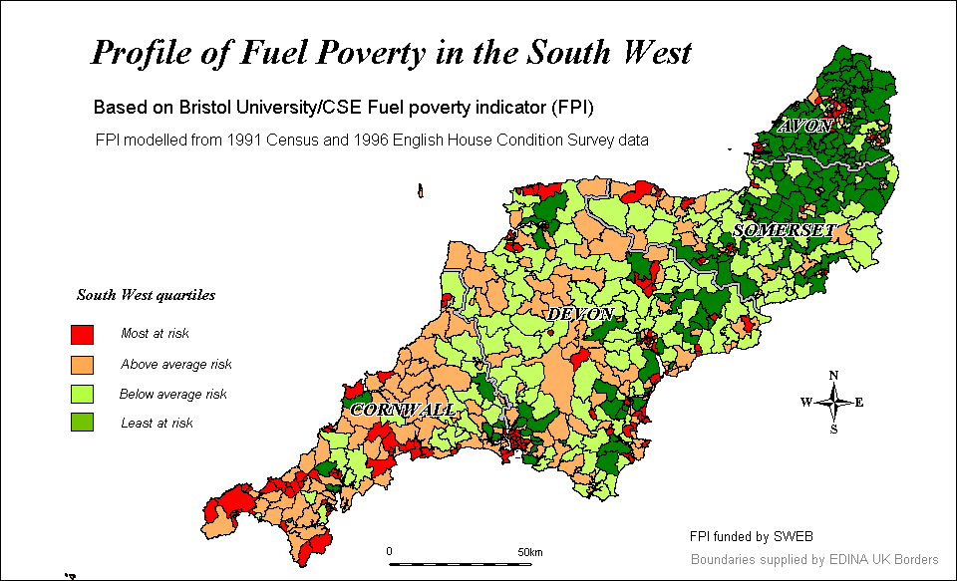
Map 1 suggests that Cornwall has the largest number of wards lying within the worst quartile for fuel poverty in the South West, when comparing the four counties. Only a small number of wards in Cornwall have levels below the South West average. This is not surprising, given the extensive levels of deprivation in the County. However, Devon has the highest level of fuel poverty among the 4 counties (see Table 3 below).

The two findings may seem contradictory. The explanation lies with the extensive level of fuel poverty in Plymouth (26.9%), probably a reflection of extensive general deprivation in the city. Plymouth also accounts for a quarter of Devon’s population, therefore pushing up Devon’s overall fuel poverty figure. If Plymouth is excluded from Devon’s results, the proportion in fuel poverty falls to 22.8%.

Map 1 also shows that there are extensive levels of fuel poverty in Plymouth and Bristol (see Appendix 2 for more detailed maps of Devon and Avon). The majority of wards in both cities are in the worst quartile within the South West.

Table 3: Fuel poverty in the four South West counties
 | No. of households in fuel poverty | % in fuel poverty
Avon | 78,182 | 20.6
Somerset | 38,109 | 20.5
Devon | 107,075 | 25.8
Cornwall | 45,489 | 24.1
South West | 268,885 | 23.0
England | 4,354,275 | 23.1
Note: Cornwall does not include the Isles of Scilly

‘Concentrations’ of fuel poverty

Map 2 shows those wards that fall within the ‘worst’ 10% of wards in the South West. Concentrations that particularly stand out are in the far West of Cornwall, much of Plymouth, parts of Torbay and Exeter, Weston Super Mare and inner Bristol. The predicted level of fuel poverty for each ward falling within the ‘worst’ 10% is given in Appendix 3. 72 wards are listed.

St Peter’s ward in Plymouth has the highest score on the FPI at 38.5%. It also falls within the worst 1% of wards, with respect to fuel poverty, in England. Of the ten worst wards in the South West, with respect to fuel poverty, six lie in Plymouth (see Appendix 3). This illustrates the severity of the fuel poverty problem in Plymouth.

Map 2
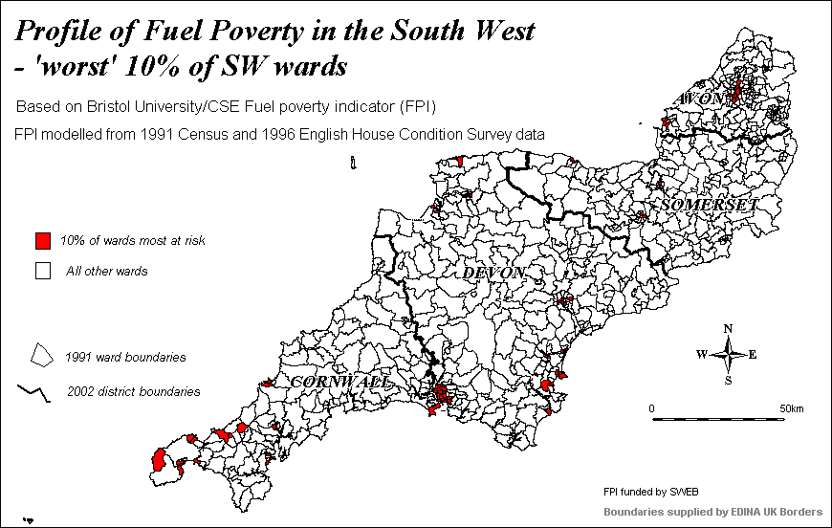

Comparing fuel poverty in the South West and England

Table 4 below shows that 38 South West wards fall within the ‘worst’ 10% of wards in England, with respect to fuel poverty. Table 4 also gives each ward’s rank in England (there are approximately 8700 wards in England). If the pattern of fuel poverty in the South West was the same as England as a whole, the number of wards in the worst 10% of English wards would have been 72, given that there are 720 wards in the South West.

Table 3 above shows that the proportion of households in fuel poverty in the South West was 23.0%. This is very similar to the English average of 23.0%. The 1996 English House Condition Survey suggests that the South West ranks 5th out of the 9 English regions, with respect to fuel poverty (DETR, 2000a).

Table 4: South West wards in the ‘worst’ 10% of wards in England
District | Ward | Rank in Eng. | District | Ward | Rank in Eng.
Plymouth | St.Peter | 85 | East Devon | Exmouth Littleham Urb’ | 511
Plymouth | Sutton | 114 | Bristol | Ashley | 550
Penwith | Penzance East | 124 | Exeter | Whipton | 565
Exeter | Wonford | 133 | Woodspring | Weston-Super-Mare S. | 578
North Devon | Ilfracombe Central | 198 | Penwith | St.Ives North | 578
Penwith | Penzance West | 210 | Woodspring | Weston-Super-Mare E’ | 619
Carrick | Penwerris | 229 | Torbay | Tormohun | 633
Plymouth | Mount Gould | 258 | Plymouth | Budshead | 650
Plymouth | Keyham | 290 | Torbay | Coverdale | 666
Exeter | Rougemont | 317 | Bristol | Filwood | 701
Penwith | Penzance Central | 329 | East Devon | Exmouth Withycombe Urb’ | 738
Plymouth | Stoke | 341 | Bristol | Easton | 766
Plymouth | Drake | 367 | Penwith | Marazion | 786
Penwith | St.Ives South | 400 | Teignbridge | Teignmouth West | 786
Bristol | Lawrence Hill | 420 | Kerrier | Redruth North | 827
Exeter | Polsoe | 444 | Exeter | St.Thomas | 827
Bath | Abbey | 477 | Torbay | Ellacombe | 839
Teignbridge | Teignmouth East | 496 | Kerrier | Camborne North | 859
Torridge | Appledore East | 496 | Sedgemoor | Eastover | 859

Conclusion

Further comparative analysis of scores on the FPI is possible, for example local authority districts and parliamentary constituencies. Such analysis can easily be conducted by consulting the raw data on CSE’s website. However, the results will only be approximate since there will be inaccuracies due to rounding errors. Accuracy can be improved by obtaining denominators from the Census Dissemination Unit at MIMAS (University of Manchester). This source was used for the above analysis of counties. Accuracy could be further improved by re-running our model at the geography required. This was not carried out for the above exercise.

The above analysis mainly relates to electoral wards. This has limitations due to the wide variation in population size between wards. In the South West, for example, ward populations can vary from 1000+ to over 11,000. The analysis therefore does not necessarily reflect the extent of need, as assessed by absolute numbers in fuel poverty. However, the FPI can be used to compare absolute numbers.

It may be appropriate to consider targeting anti-fuel poverty programmes through the use of enumeration district results for the FPI. CSE would be happy to conduct such an analysis as a ‘be-spoke’ service. However, such analysis is limited by the age of the datasets used for the FPI and the likelihood of anomalies appearing when applying the FPI at such a small area. This problem will be considerably reduced when the indicator is updated with data from the 2001 Census and EHCS, as described earlier.

REFERENCES

Boardman, B (1991), Fuel poverty: from cold homes to affordable warmth, Belhaven Press

Bramley, G; Lancaster, S; Gordon, D (2000), ‘Benefit take-up and the geography of poverty in Scotland’, Regional Studies, Vol 34.6, pp 507-519

CSE (2001), Profile of vulnerable customer groups in the South West, CSE report to SWEB (unpublished)

CSE (2001a), Competitive energy markets and low income consumers, CSE

DETR (2000a), English House Condition Survey. 1996 Energy report, DETR

DETR (2000b), Response to the formal consultations on the Indices of Deprivation 2000, DETR

DTI/DEFRA (2001), The UK Fuel poverty strategy, DTI/DEFRA

DTI/DEFRA (2002), Fuel poverty in England in 1998, DTI/DEFRA

DTLR (2002a), EHCS Bulletin, 3

DTLR (2002b), Index of Multiple Deprivation, Office of National Statistics

DWP, 2002 Income Related Benefits Estimates of Take-Up in 1999/2000

Electricity Association Fuel Poverty Task Force (2001), Prepayment meters. Fact not fiction, Electricity Association

Energy Saving Trust (2002), Warm Zones – external evaluation by CSE & NEA, publication forthcoming

Gordon, D (1995) ‘Census based deprivation indices: their weighting and validation’, Journal of Epidemiology and Community Health, 49 (Suppl 2)

Gordon, D (2002), Predicting fuel poverty at small area level, publication forthcoming

Gordon, D and Forrest, R (1995), People and Places Volume II: Social and Economic Distinctions in England - A 1991 Census Atlas, Bristol, SAUS and the Statistical Monitoring Unit

Lawlor, D; Harvey, D; Dews, H (2000), Investigation of the association between excess winter mortality and socio-economic deprivation, (check publisher with Debbie)

LE Group (2002), Identifying and helping vulnerable customers, LE Group

Martin, J (1990), ‘Asking about money: ESRC survey methods seminar series’, Joint Centre for survey methods newsletter, 10,2,2

National Energy Action (2001), Annual Review, NEA

National Energy Action (2000), Assessing fuel poverty, NEA Discussion Paper

National Right to Fuel Campaign (2000), Fuel poverty fact file, NRFC

National Right to Fuel Campaign (2002a), Fuel poverty definition - using
disposable income, NRFC Position Paper

National Right to Fuel Campaign (2002b), Too big to be warm, publication forthcoming

Ofgem (2001), Experience of the competitive market – the domestic electricity and gas markets, Ofgem

Shah, S & Peacock, J, (1999), ‘Deprivation and excess winter mortality’, Journal of Epidemiol Community Health, 53

Townsend, P., Phillimore, P. and Beattie, A. (1988) Health and deprivation: inequality in the north. London: Croom Helm.

Wilkinson, P., Landon, M., Armstrong, B., Stevenson, S., Pattenden, S., Fletcher, T. and McKee, M. (2001) Cold comfort: The social and environmental determinants of excess winter death in England, 1986-96. Policy Press

APPENDIX 1 – Comparison of FPI with other indicators

We have conducted some limited analyses that compare the FPI with related indicators. We only offer brief comments on the charts produced. However, we would welcome the opportunity to undertake more detailed analysis in the future. The following is meant to give a ‘flavour’ of the type of analyses researchers might wish to conduct.

Comparison of the FPI with ‘general’ deprivation indicators

Graphs 1, 2 and 3 illustrate the correlations between the FPI and:
- the Breadline Britain deprivation indicator
- the Index of Multiple Deprivation (IMD)
- the income domain with the IMD

The graphs show that the FPI is clearly related to general deprivation, as measured by a variety of indicators. However, it is notable the plots tend to ‘splay out’ towards the higher scores. This suggests that whereas affluent areas are generally not fuel poor, deprived areas display quite a wide variation in fuel poverty rates. This could have important implications for the targeting of anti-fuel poverty programmes.

Graph 1: FPI against Breadline Britain deprivation indicator

Graph 2: FPI against IMD score

Graph 3: FPI against ‘income domain’ (IMD)
Graph 4 below shows the correlation between the FPI and the ‘health and disability’ domain within the Index of Multiple Deprivation. The graph suggests there is a degree of correlation between the two indicators.

CSE used the ‘health and disability’ indicator for an earlier study for SWEB of the distribution of ‘vulnerable groups’ (CSE, 2001). Map 3 below shows the distribution of the indicator in map format.

It is interesting to compare Map 3 with Map 1. Although there are obvious similarities, there are significant differences in terms of the ‘patterns’ of distribution revealed. For example, there are pronounced concentrations of health and disability deprivation in North Cornwall. Fuel poverty does not appear to be so concentrated in this area. This has implications for targeting. For example, some programmes may wish to target disabled low income energy consumers, whereas others may wish to target the ‘fuel poor’ in general.

Graph 4: FPI against ‘health and disability’ deprivation (IMD)
Map 3:

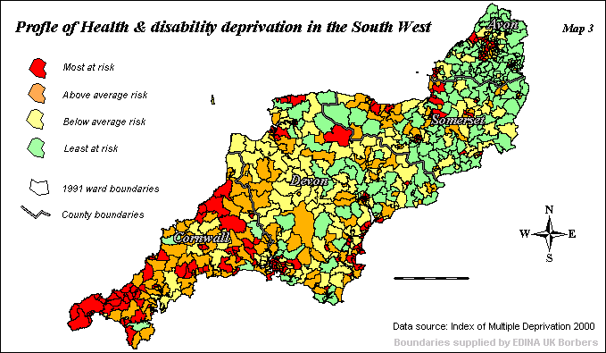

Comparison of FPI with incidence of prepayment meters

Chapter 2 discussed various issues relating to the possible association between use of prepayment meters (ppms) and fuel poverty. Graphs 5 and 6 below show the extent of correlation between the two indicators. We produced the indicator ‘% using ppms’ by converting postcode data supplied by SWEB to ward data. The conversion was only approximate. The indicator therefore contains anomalies, particularly at the extremes. Because of this, certain ‘outliers’ were excluded, namely wards where more than 55% of households paid by ppm (about 5 wards out of 720).

Graph 5: FPI against % paying by prepayment meter
Graph 6: Income domain (IMD) against % paying by prepayment meter
Graph 5 suggests that the FPI is not strongly associated with incidence of households paying by ppm. However, Graph 6 suggests a stronger association with low income, as defined by households claiming benefits (the income domain within the IMD).

This finding suggests that ppm use is more strongly associated with income deprivation than it is with fuel poverty. It is possible that low income households living in relatively energy efficient houses might still choose to pay by ppm because of the advantages afforded by the budgeting facility. We speculate that the strongest motivation for such households is to minimise anxieties about paying bills, even if such bills are relatively modest.

It would be useful to further research some of these issues in greater depth. We suggest that measures of ‘satisfaction with payment method’ do not adequately reflect all the issues relating to ppm use, e.g. higher cost of use, lack of competitive offers, self-imposed rationing, inconvenience (travelling to ppm card charging point), risk of self-disconnection etc. Users may well express high satisfaction levels; however, this may reflect the lack of any alternative convenient budgeting facility on offer from companies.

Comparison of FPI with excess winter deaths

Debbie Lawlor of Bristol University’s School for Social Medicine has produced seasonal mortality ratios for all wards in the South West. The ratio (essentially a measure of excess winter deaths) represents the mean age sex standardised death rate in winter months over the mean age sex standardised death rate in non-winter months for 5 years data (ask Debbie). Five years data was combined because analysis of a single year’s data would have involved very small numbers at the individual ward level.

As stated earlier, previous research has shown little association between general deprivation and excess winter deaths (Lawlor et al, 2000; Shah et al, 1999). Graph 7 below, a comparison of Lawlor’s index with the IMD’s income domain, appears to confirm previous research.

We also investigated the relationship between the FPI and excess winter deaths. We speculated that a fuel poverty measure might prove a better indicator of seasonal mortality than a general deprivation measure. Graph 8 below suggests that this is not the case. There does not appear to be any significant association between fuel poverty and seasonal mortality.

Graph 6: Seasonal mortality ratio against income domain (IMD)
Graph 8: Seasonality mortality ratio against FPI
The two graphs suggest that neither area deprivation nor incidence of fuel poverty appear to be a useful way of identifying areas that are likely to have high levels of seasonal mortality. Again, this is an issue that needs further investigation. The finding seems counterintuitive, given that other research has found an association between winter mortality and poor housing (e.g. Wilkinson, 2001) and between poor housing and deprivation (e.g. Gordon & Forest, 1995).

Further investigation of households most at risk of winter mortality might shed light. For example, risk rises considerably for those aged 85+, who account for a large proportion of the total figure (ask Nick ). It is possible that many people in this age band do not originate from deprived groups, due to the general association between deprivation and mortality. For now, a plot of the incidence of winter mortality shows some interesting patterns (see Map 4 below)
Map 4
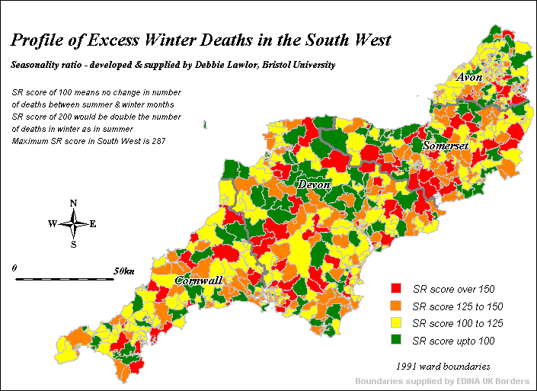

The most striking feature of Map 4 is that virtually all of the wards with seasonal mortality ratios above 150 are rural. Is there some feature of rural areas that means rural households are more prone to winter mortality? We suggest that the finding is not just an anomaly that might have arisen due to the compilation of the source data. The rural feature appears systematically across the whole of the South West. Only 3 wards in Penzance, Plymouth, Torbay, Exeter, Taunton, Bristol, Bath combined appear have ratios above 150 (there are 111 wards in total in the 7 urban areas).

Not one ward in Plymouth had a seasonal mortality ratio above 150, despite the fact that Plymouth has the worst district fuel poverty rate in the South West. The ward with the highest seasonal mortality ratio was Milton Ford in West Devon. It is notable that this is a particularly remote rural ward.

It is also notable that there are a substantial number of wards with no seasonal mortality ratio effect (163 wards across the South West, coloured green on Map 4), i.e. these wards. Thus, there is no difference (or even a negative difference) in the death rates between the winter and summer months for over one fifth of wards in the South West.

There are also wards with ratios above 150 geographically adjacent to wards with ratios below 100. This might suggest that outdoor temperatures (which must be similar for neighbouring wards) are less important in determining ward level excess deaths than housing or indoor temperatures.

Map 4 and Graphs 5 and 6 all suggest that the whole area of excess winter deaths needs considerably more research. One far reaching implication might be that policy instruments designed to eliminate fuel poverty might only have a limited impact on reducing excess winter deaths.

APPENDIX 2 – County Profiles
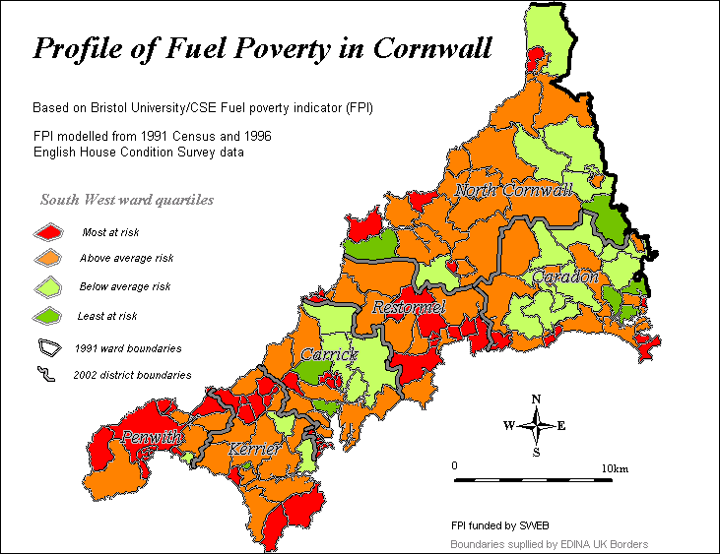

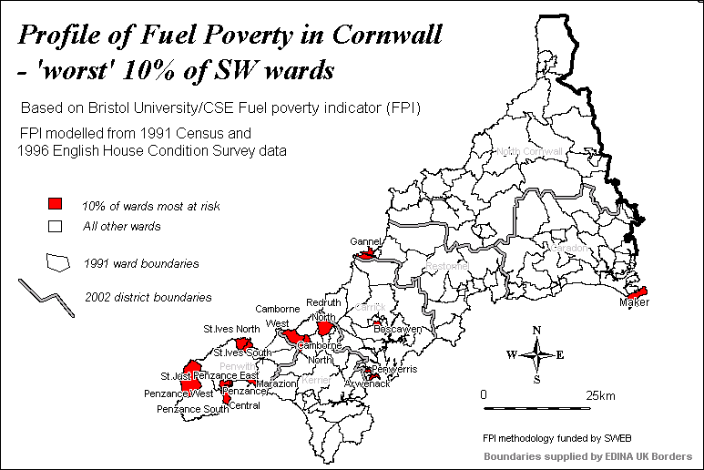
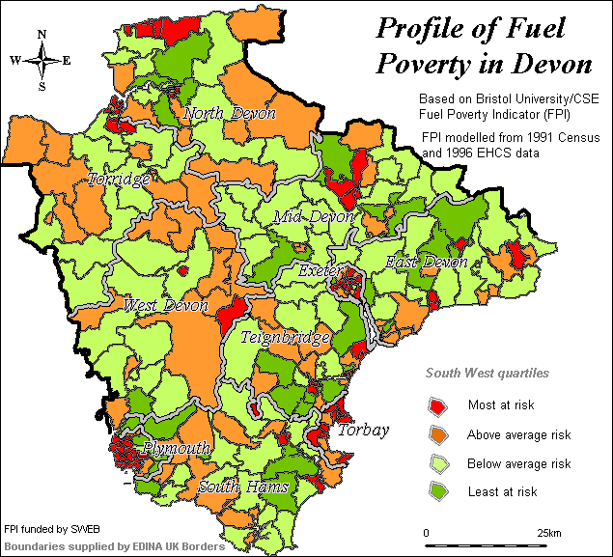

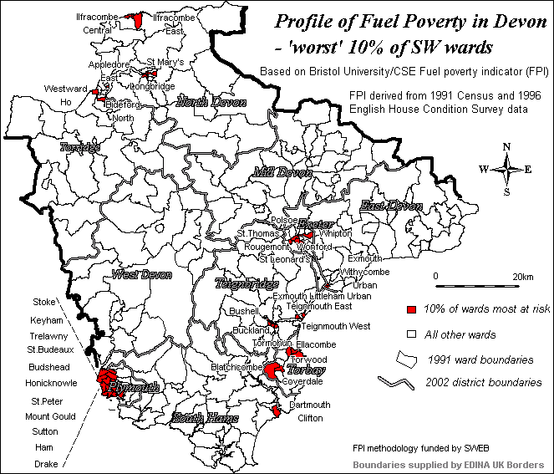
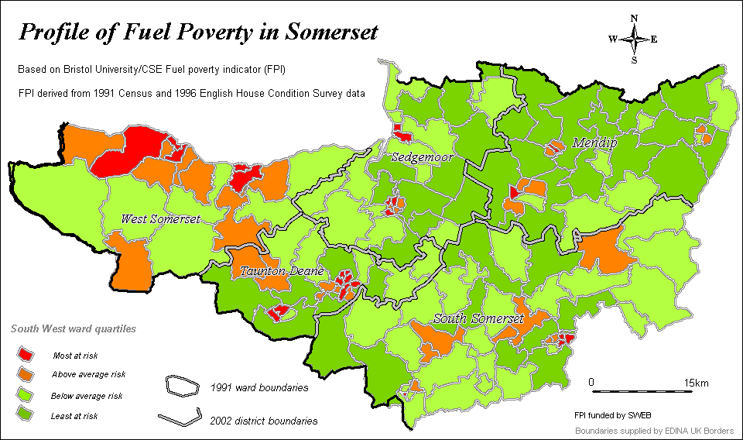

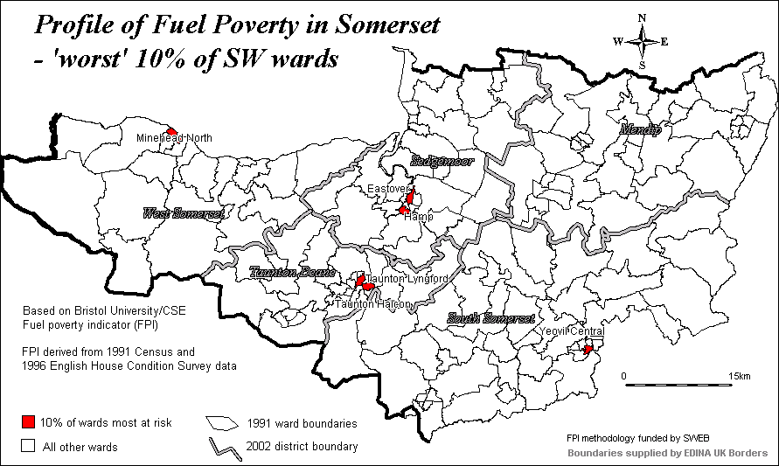

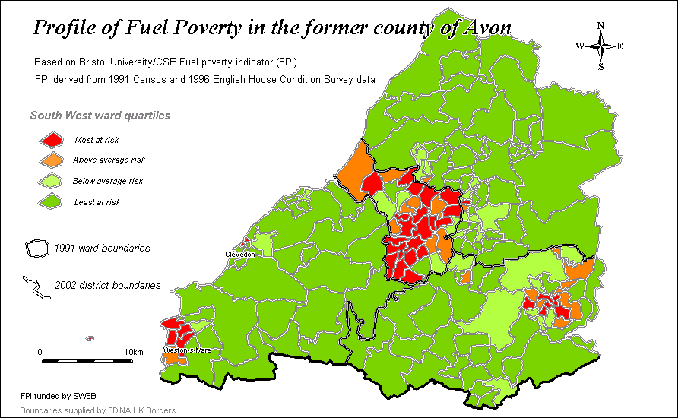

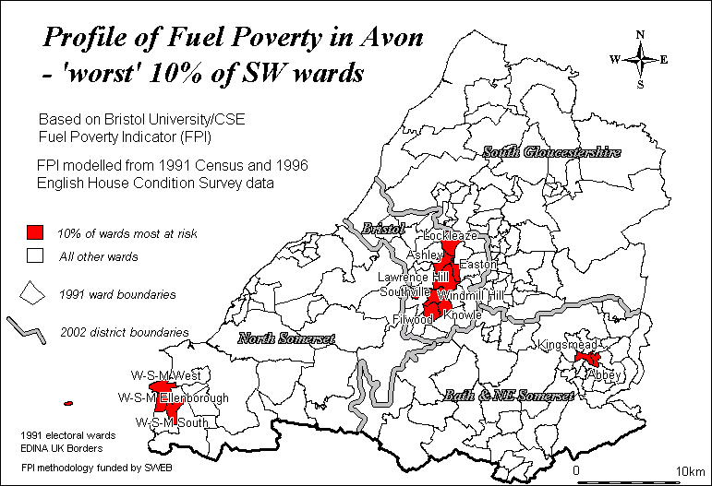

APPENDIX 3 – ‘Worst’ 10% of wards in South West

District | Ward | % in fuel pov | No in fuel pov | No of h/hds | Rank
Plymouth | St.Peter | 39.5 | 2102 | 5317 | 1
Plymouth | Sutton | 38.5 | 1933 | 5014 | 2
Penwith | Penzance East | 38.2 | 830 | 2176 | 3
Exeter | Wonford | 37.8 | 735 | 1942 | 4
North Devon | Ilfracombe Central | 36.6 | 550 | 1504 | 5
Penwith | Penzance West | 36.4 | 551 | 1515 | 6
Carrick | Penwerris | 35.9 | 819 | 2283 | 7
Plymouth | Mount Gould | 35.5 | 1554 | 4378 | 8
Plymouth | Keyham | 35.1 | 1698 | 4841 | 9
Exeter | Rougemont | 34.7 | 985 | 2840 | 10
Penwith | Penzance Central | 34.6 | 524 | 1515 | 11
Plymouth | Stoke | 34.4 | 1789 | 5202 | 12
Plymouth | Drake | 34.2 | 1869 | 5458 | 13
Penwith | St.Ives South | 33.9 | 498 | 1468 | 14
Bristol | Lawrence Hill | 33.6 | 2002 | 5959 | 15
Exeter | Polsoe | 33.4 | 696 | 2081 | 16
Bath | Abbey | 33.2 | 911 | 2742 | 17
Teignbridge | Teignmouth East | 33.0 | 473 | 1433 | 18
Torridge | Appledore East | 33.0 | 159 | 480 | 19
East Devogn | Exmouth Littleham Urban | 32.9 | 520 | 1578 | 20
Bristol | Ashley | 32.6 | 1698 | 5209 | 21
Exeter | Whipton | 32.5 | 609 | 1872 | 22
Woodspring | Weston-Super-Mare South | 32.4 | 1008 | 3112 | 23
Penwith | St.Ives North | 32.4 | 474 | 1461 | 24
Woodspring | Weston-Super-Mare Ellenbo’ | 32.2 | 1130 | 3506 | 25
Torbay | Tormohun | 32.1 | 1320 | 4111 | 26
Plymouth | Budshead | 32.0 | 1587 | 4957 | 27
Torbay | Coverdale | 31.9 | 1452 | 4551 | 28
Bristol | Filwood | 31.7 | 1185 | 3735 | 29
East Devon | Exmouth Withycombe Urban | 31.4 | 541 | 1722 | 30
Bristol | Easton | 31.2 | 1470 | 4713 | 31
Penwith | Marazion | 31.1 | 200 | 643 | 32
Teignbridge | Teignmouth West | 31.1 | 439 | 1413 | 33
Kerrier | Redruth North | 30.9 | 809 | 2619 | 34
Exeter | St.Thomas | 30.9 | 739 | 2392 | 35
Torbay | Ellacombe | 30.8 | 1309 | 4254 | 36

District | Ward | % in fuel pov | No in fuel pov | No of h/hds | Rank
Kerrier | Camborne North | 30.6 | 787 | 2574 | 37
Sedgemoor | Eastover | 30.6 | 386 | 1261 | 38
Plymouth | Ham | 30.4 | 1280 | 4213 | 39
North Devon | Ilfracombe East | 30.3 | 371 | 1226 | 40
Penwith | Penzance South | 29.6 | 584 | 1975 | 41
Kerrier | Camborne West | 29.5 | 744 | 2520 | 42
Teignbridge | Bushell | 29.5 | 483 | 1636 | 43
Sedgemoor | Hamp | 29.5 | 588 | 1992 | 44
North Devon | St Marys' | 29.3 | 409 | 1398 | 45
S Somerset | Yeovil Central | 29.1 | 504 | 1733 | 46
Bristol | Windmill Hill | 29.0 | 1681 | 5800 | 47
Teignbridge | Buckland | 29.0 | 426 | 1469 | 48
Taunton D’ | Taunton Lyngford | 29.0 | 611 | 2110 | 49
Bristol | Knowle | 28.9 | 1141 | 3947 | 50
Caradon | Maker | 28.9 | 138 | 477 | 51
Penwith | St.Just | 28.9 | 532 | 1841 | 52
Restormel | Gannel | 28.9 | 670 | 2316 | 53
Plymouth | St.Budeaux | 28.9 | 1315 | 4545 | 54
Torridge | Westward Ho | 28.9 | 198 | 685 | 55
Torridge | Bideford North | 28.8 | 572 | 1986 | 56
Woodspring | Weston-Super-Mare West | 28.6 | 978 | 3415 | 57
Torbay | Blatchcombe | 28.6 | 1170 | 4091 | 58
North Devon | Longbridge | 28.4 | 196 | 690 | 59
Torbay | Torwood | 28.4 | 1233 | 4347 | 60
Taunton D’ | Taunton Halcon | 28.4 | 622 | 2193 | 61
Bath | Kingsmead | 28.3 | 677 | 2396 | 62
Bristol | Southville | 28.3 | 1307 | 4611 | 63
South Hams | Dartmouth Clifton | 28.3 | 387 | 1368 | 64
Exeter | St Leonards' | 28.2 | 720 | 2554 | 65
Plymouth | Trelawny | 28.2 | 1120 | 3976 | 66
Carrick | Arwenack | 28.1 | 360 | 1281 | 67
W Somerset | Minehead North | 28.1 | 348 | 1238 | 68
Plymouth | Honicknowle | 28.0 | 1401 | 4999 | 69
Bristol | Lockleaze | 27.9 | 1101 | 3943 | 70
Carrick | Boscawen | 27.8 | 613 | 2203 | 71
Restormel | Fowey | 27.7 | 297 | 1072 | 72

A Census Enumeration District typically consists of several hundred households. The size of area covered by an Enumeration District was typically determined by administrative concerns relating to managing enumerators’ workloads.
Analysis at this level of detail comes with a ‘health warning’. The age of the datasets used for the current version of the FPI may lead to inaccuracies due to the small numbers of households involved.
The first report was also prepared to support the SWEB/London Electricity ’vulnerable customers project’ (see LE Group, 2002).
Under occupancy is defined in terms of the 1968 Parker Morris standard which set building regulations on the minimum floor area for a home depending on the number of occupants (DTI & DEFRA, 2002a,b).
Warm Front grants cover certain insulation and heating measures and are designed to improve the energy efficiency of the recipients’ homes.
The profile also included an analysis of a third indicator – ‘pensioner poverty’. This indicator was constructed by combining two databases: pensioners on Income Support and population over 60.
However, 87% of gas ppm users have arrears. The difference between gas and electricity reflects fuel company policy. Gas companies only install ppms in the homes of debtors, whereas electricity companies offer ppms as a payment option to all consumers.
Website addresses: cse.org.uk and
Website: http://census.ac.uk/cdu
Website: http://census.ac.uk/cdu
See Gordon, 1995, for further explanation of the Breadline Britain deprivation indicator.
The ‘income domain’ essentially measures the number of households claiming means-tested benefits by ward.
CSE also examined the distribution of ‘child poverty’ and ‘pensioners in poverty’.
Wards in Map 4 are divided into natural breaks on the seasonal mortality index. A ratio of 100 means summer and winter mortality ratios are the same. A ratio of 150 means there are three deaths in winter for every two in summer. Most of the other maps are based on equal counts of wards.
Please note that the analysis did not involve a systematic split between urban and rural wards in the South West. This would require a more extensive research study.

